A000 Asia-Indus-Mehgarh-Bos Indicus-Terra Cotta-2900 BCE

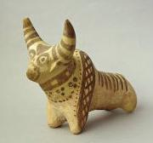

Fig. 1. Indus-Bull-Figurine-Terracotta-2900 BCE

**Case no.: 3**

**Accession Number:**

**Formal Label:** Indus-Mehgarh-Bos Indicus-Terra Cotta-2900 BCE

**Display Description:**

Terra cotta zebu bulls have their surfaces painted by dark, painted lines (usually black or brown), that emphasize their dorsal ridge, their hump, and their elongated snout. Terracotta figurines such as this one have been unearthed at Mohenjo-daro and Harappa as well, suggesting a commonality of style and purpose throughout the Indus Valley during the mature Harappan period (ca. 2600-2450 BCE). One excavated example from Chanhu-daro has a puncture in the abdomen, suggesting it had been used as a miniature standard similar to those depicted on some stamp seals. For comparable examples see Aruz 2003: no.276, p.390.

**LC Classification:** PK119

**Date or Time Horizon:** 2900 BCE

**Geographical Area:** Mehrgarh

**Map, GPS coordinates: 29.38716 67.60955; 29º23'13.77" N 67º36'34.37" E**

**Cultural Affiliation:** Indus Civilization

**Media:** Terra cotta, paint

**Dimensions:**

**Weight:**

**Condition:**

**Provenance:** Mehrgarh

**Discussion:**

During Neolithic Period I lower strata (ca 5000 BCE) a predominant percentage of bones are from wild animals: gazelles (Gazella dorcas), wild goats (Capra aegagrus), wild sheep (Ovis orientalis) and wild cattle (probably Bos nomadicus), the large antelope (Boselaphus tragocamelus) and the swamp deer (Cervus duranceli). Neither of the two last species is represented in the upper deposits of Period I (middle), and the reduced size of the cattle, sheep and goat bones indicates that by then all three of those animals were domesticated. By Period II (ca 4500 BCE), domesticated zebu cattle have become economically dominant. A transformation not only in the development of animal husbandry that had begun with a shift from wild faunal assemblages to domesticated faunal assemblages at the end of Neolithic Period I ca. 4000 BCE has occurred.

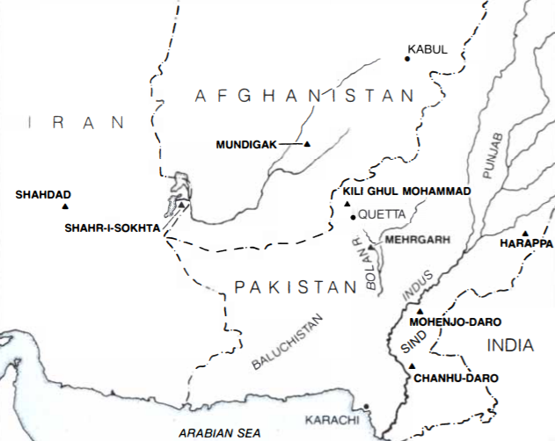

Fig. 2. Map of Mehrgarh on the Bolan River, near the western margin of the Indus plain in the Baluchistan region of central Pakistan. From Jarrige and Meadow 1980.

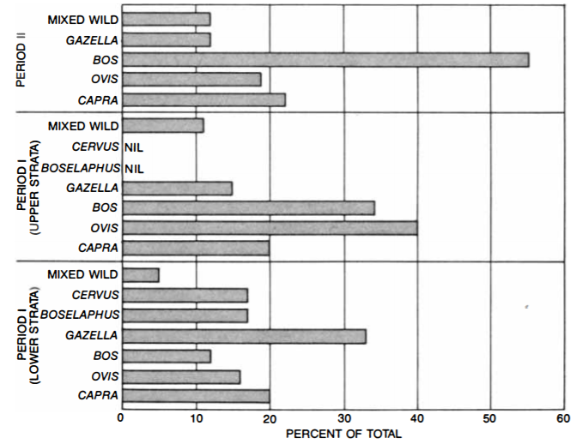

Fig. 3. Neolithic Mehrgarh faunal bone recovery from site MR2. From Jarrige and Meadow 1980.

By the end of Neolithic Period I, the bone remains of domesticated *Bos indicus* or humped zebu cattle are 12 % of the total. By the end of the first phase of Period II they are 35% of the total, and by the end of period II (4000 BCE) they are 55% of the total. This increase in the consumption of zebu cattle coincides with the manufacturing of terra cotta *Bos indicus* figurines.

By the beginning of Period VII ca 2700 BCE a cult of zebu cattle appears to have emerged from the later Neolithic Period, where zebu cattle assumed the primary role in sustaining the food supply of this Indus city. The large scale manufacture of these zebu cattle figurines suggests that they represented cultic votive objects that correspond to a largely unrecovered ritual literature.

**References:**

Aruz, J. and Ronald Wallenfels, eds. 2003. *Art of the Ancient Cities: the third millennium B.C. from the Mediterranean to the Indus*. New York, N.Y.: Metropolitan Museum of Art; New Haven, conn. ; London: Yale University Press

Jarrige, Jean-François and Richard H. Meadow. 1980. “The Antecedents of Civilization in the Indus Valley,” *Scientific American*, 243(2, August): 122-137.

Kenoyer. J. 1998. *Ancient Cities of the Indus Valley Civilization*. Karachi: Oxford University Press; Islamabad: American Institute of Pakistan Studies.